Intermountain Society of Artists0919
Membership Application ~ 2021
(please print clearly)

Name

Address

Phone

Email ___________________________________ Website ____________________________

Tell us what opportunities you want from ISA:

Artist Presentations/Demonstrations
Workshops by Prof Artist (cost determined by artist)
the Business of Art
Group Paint-outs
Opportunities to show and sell your art
Other (describe) _________________________________________________________

We want your help: You Are Priceless!‘Together we can do so much.’ -Helen Keller
Secretary - Name Tags
Secretary – record meeting notes
Hospitality / Refreshments – Set up table monthly
Organize a Paint-Out Group - one time or more
Publicity & Advertising - design an invitation or an advertisement
Help with Art Shows – find venues, organize, plan

Annual Membership: (Circle One)

Regular Senior (65+) Young Artist (<26)
- New or Renewed $45 $35 $25
- If joining in July or after $30 $20 $15

From: Name ___________________________ Amount PAID $________
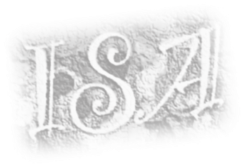
Payment Date: _______________________
Mail to:ISA (Intermountain Society of Artists)
P.O. Box 9419
Mill Creek Branch, UT 84109

